**DB2 PROJECT 2 PHASE 1**

**Team Members for Group 1:**

|  |  |
| --- | --- |
| **Name** | **ID** |
| Elsy Fernandes | **1001602253** |
| Maria Lancy Devadoss | **1001639262** |

**Step 1: -**

**MongoDB is Installed on Our system as shown below: -**

After successfully installing mongo dB on your system: -

Go to->terminal-> type **mongo --port 27017**

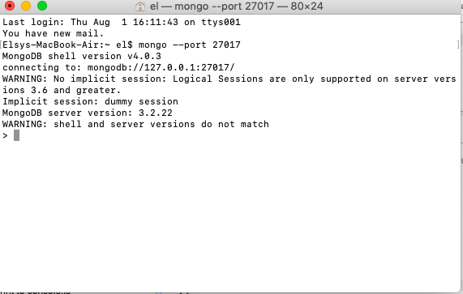

**Step 2: -**

Install **NOSQL booster** on your system and connect to mongo dB localhost server using **NOSQL booster**.

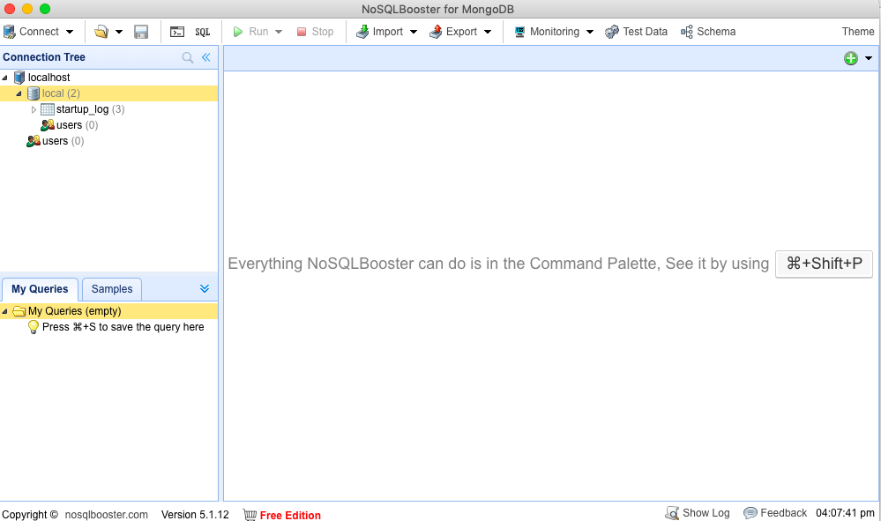

**Step 3: -**

**Create database named ‘soccer’**

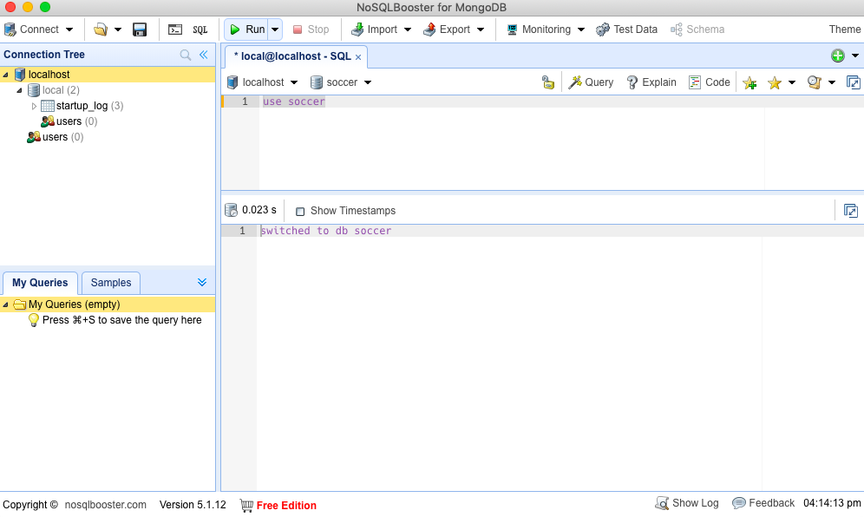

**Step 4: -**

**Create Collections**

1. Create collection ‘TEAM’ under soccer database

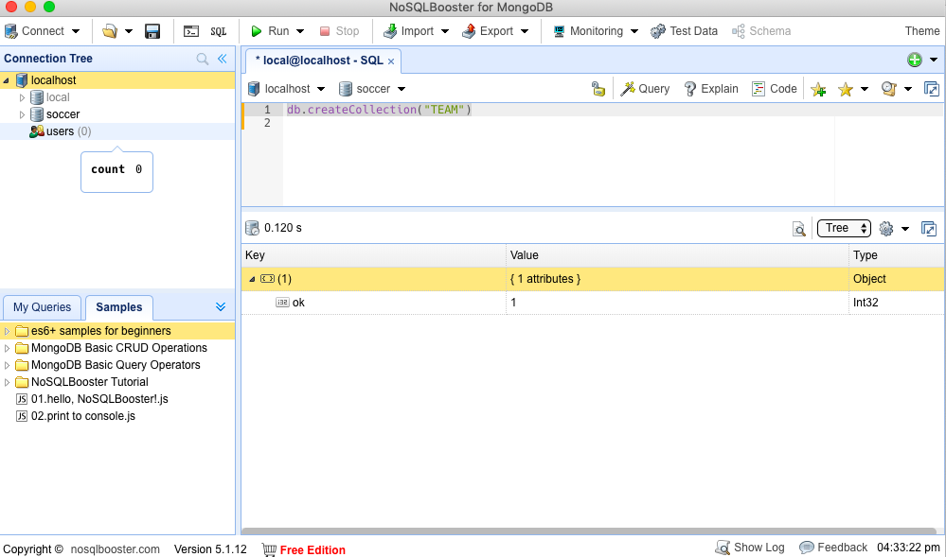

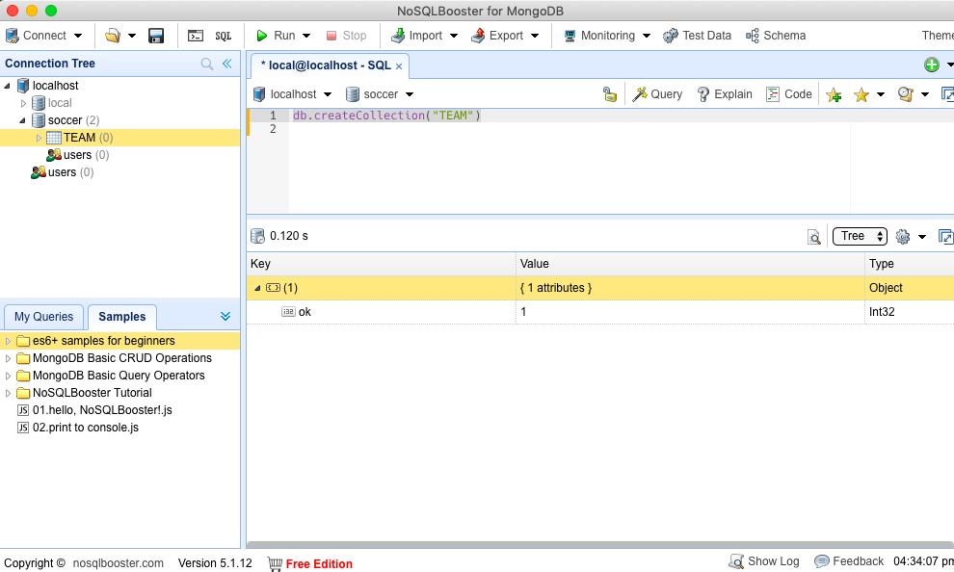

1. List the database in mongo dB

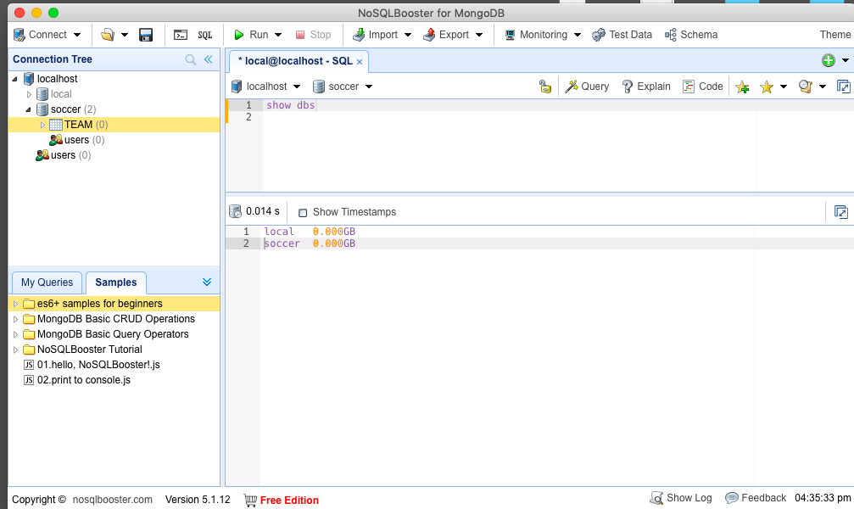

1. Create collection ‘GAME’ under soccer database

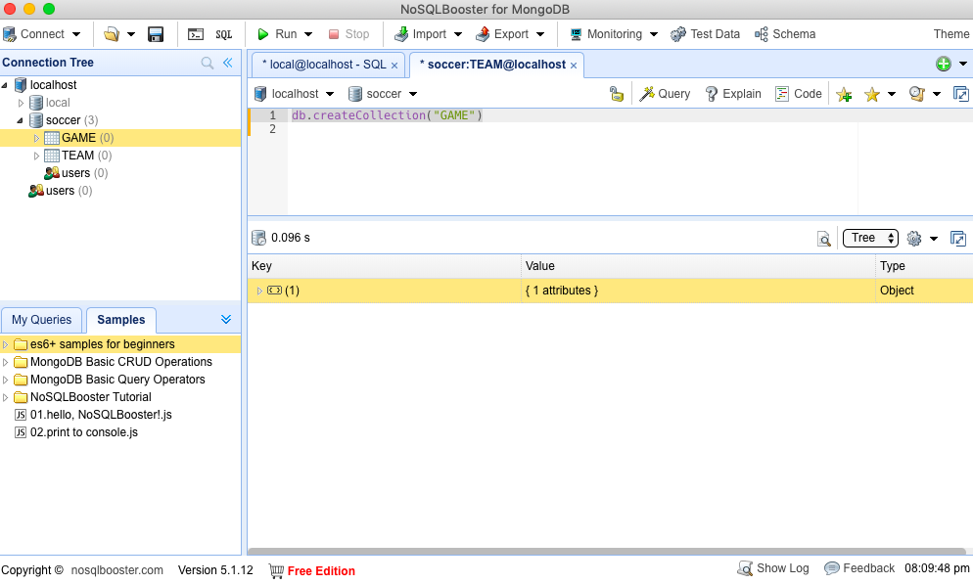

1. Create collection ‘PLAYER’ under soccer database

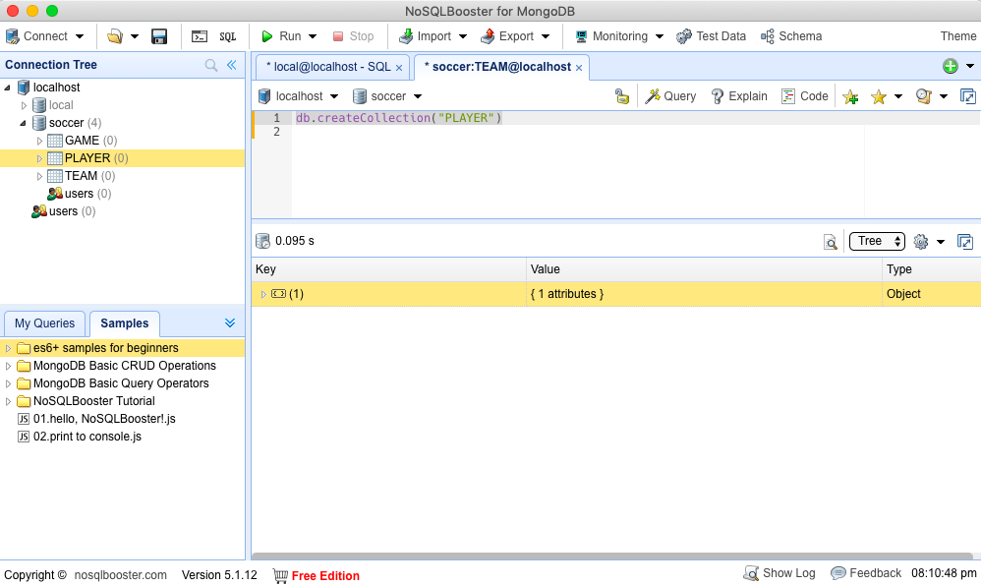

1. Create collection ‘STARTING_LINEUP’ under soccer database

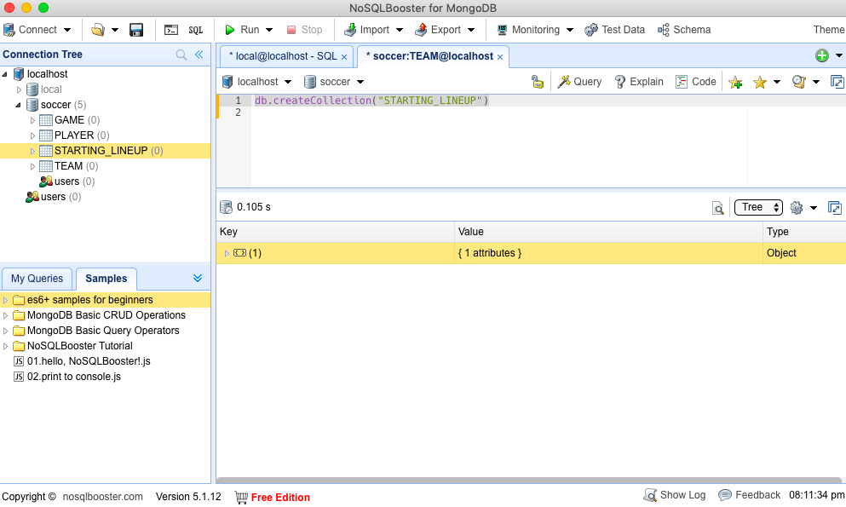

1. Create collection ‘GOALS’ under soccer database

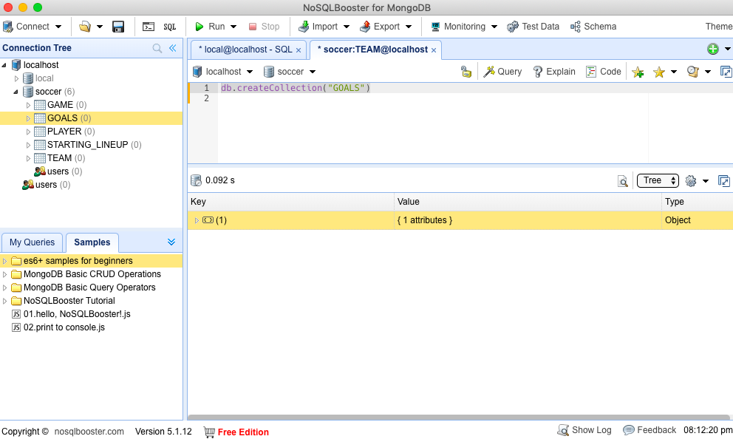

1. Create collection ‘OWN_GOALS’ under soccer database

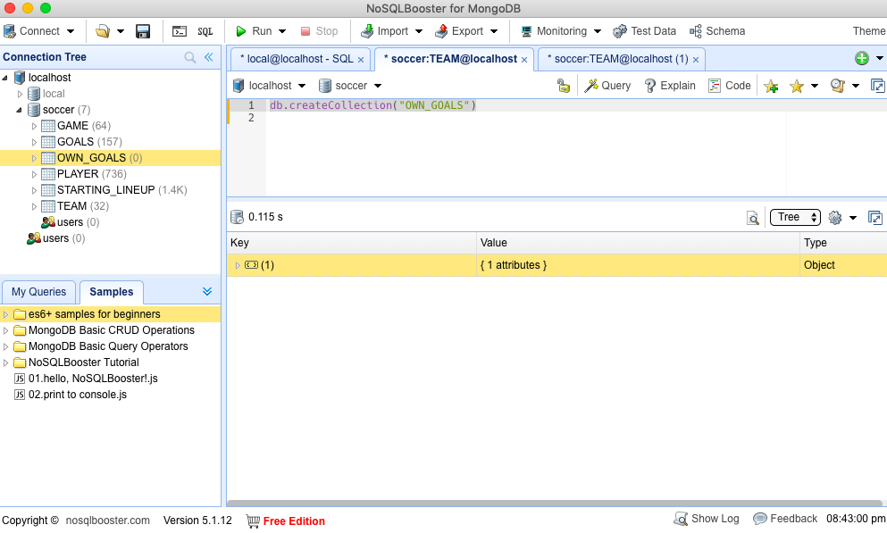

1. Create collection ‘STADIUM’ under soccer database

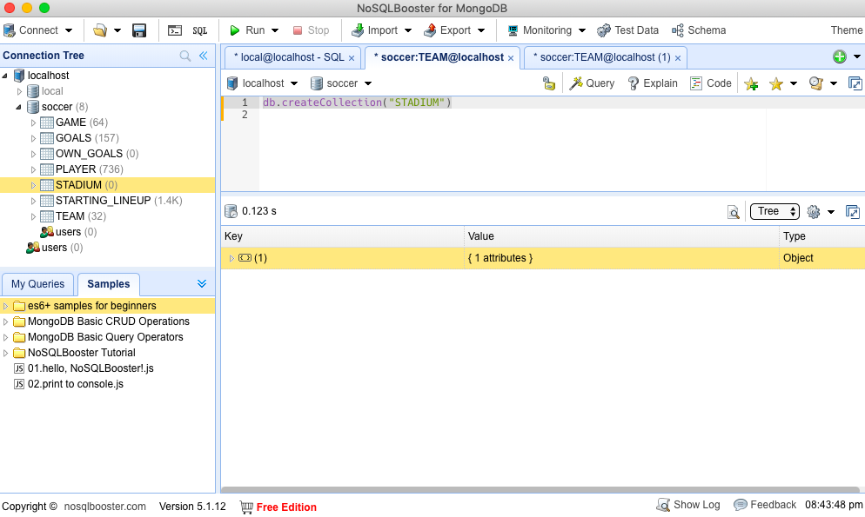

1. Create collection ‘CARDS’ under soccer database

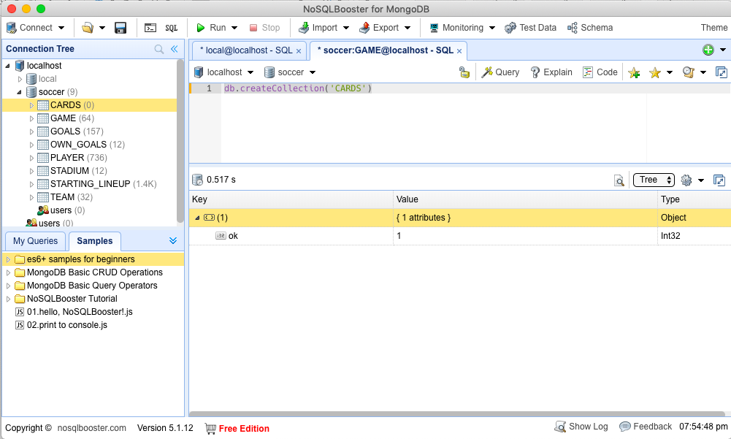

1. Create collection ‘EXTRAS’ under soccer database

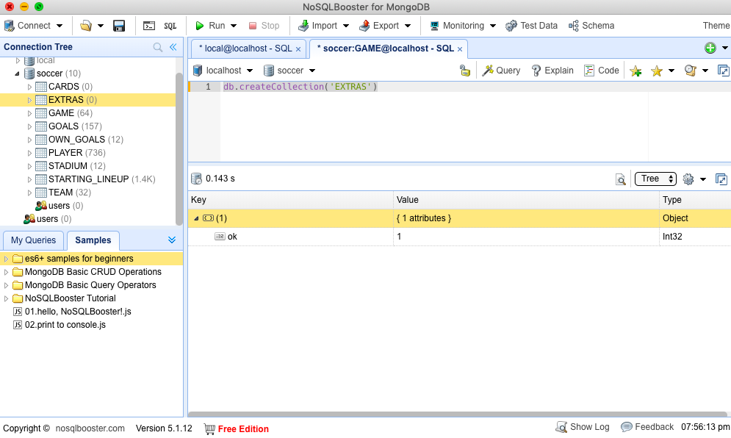

1. Create collection ‘SUBSTITUTE’ under soccer database

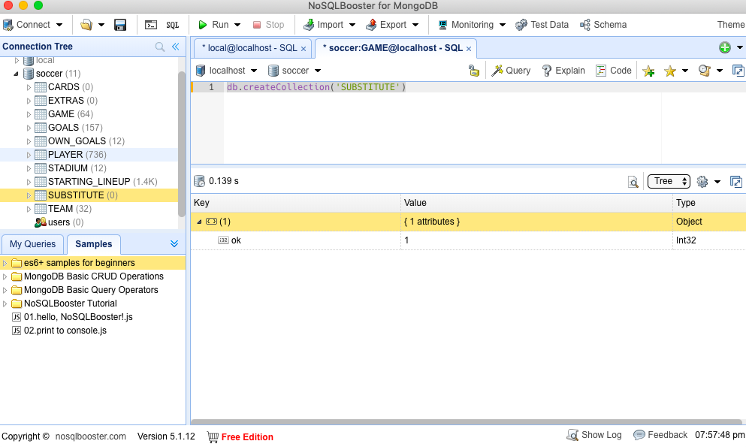

**Step 5: -**

**Import CSV files into the collections**

1. Import world-cup-teams.csv into **TEAM** collection

Right click on a collection: -

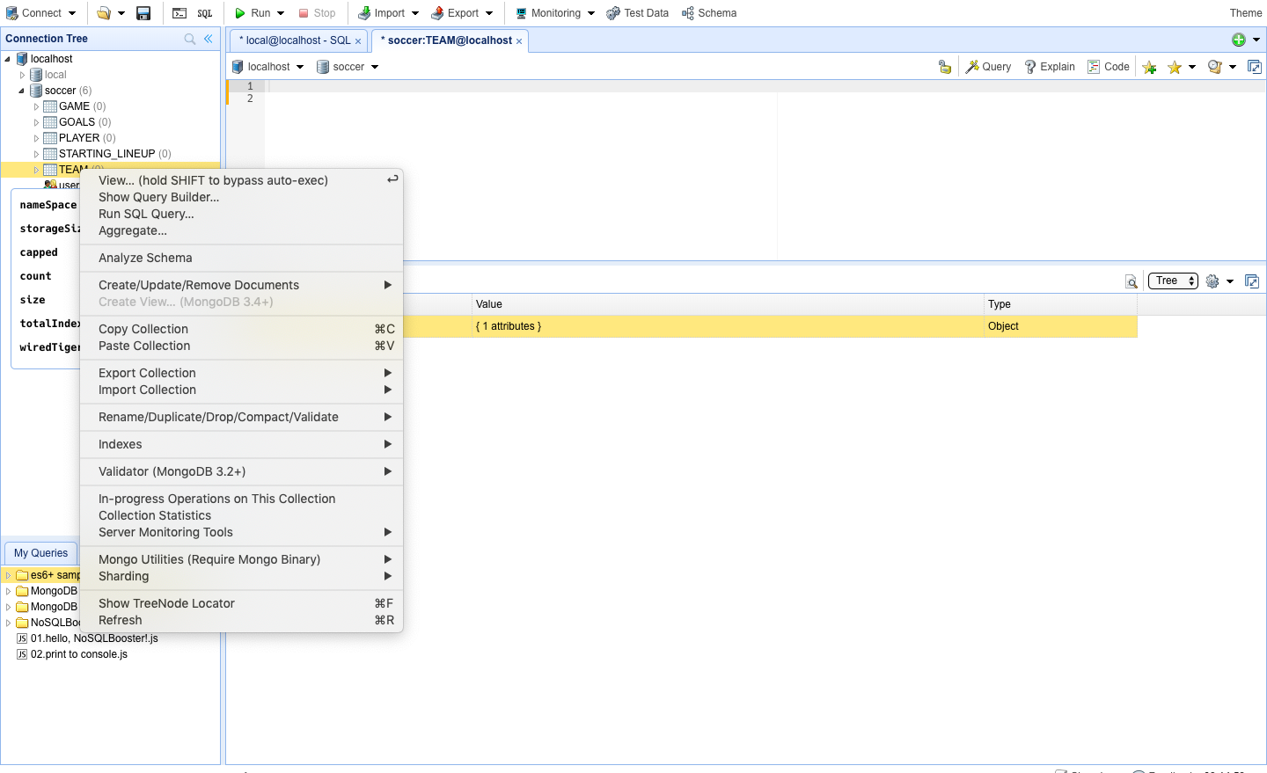

Click on Import Collection> Mongo export utility

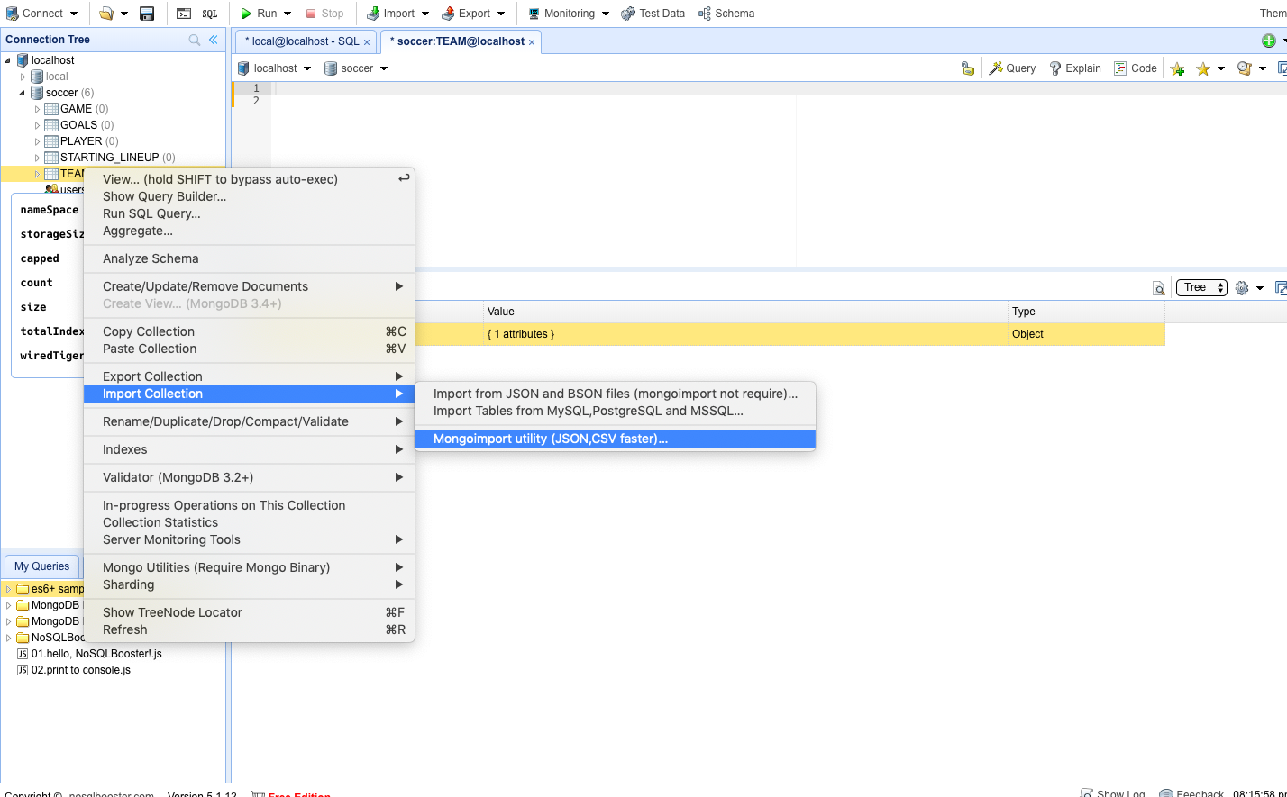

Select the location of csv file and Click on Import

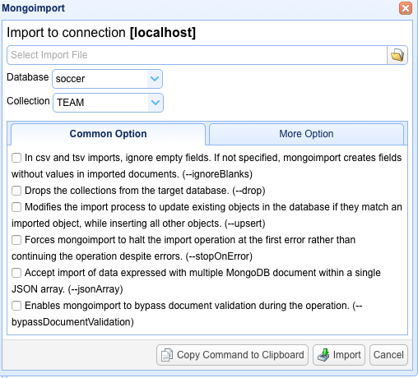

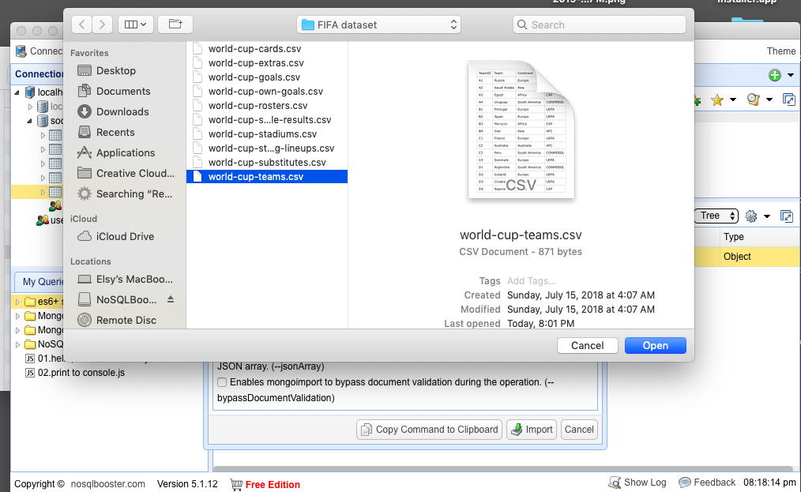

Click on Import

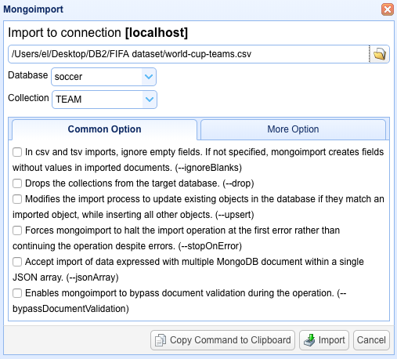

Click on Yes

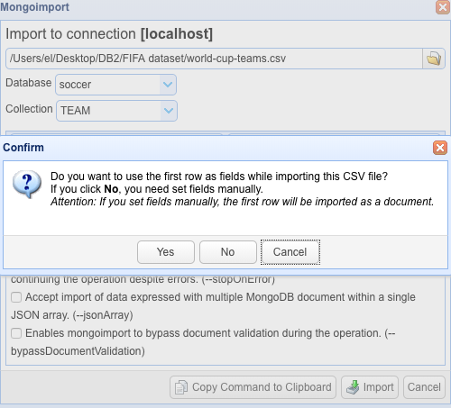

All 32 Documents are imported into collection ‘**TEAM’**

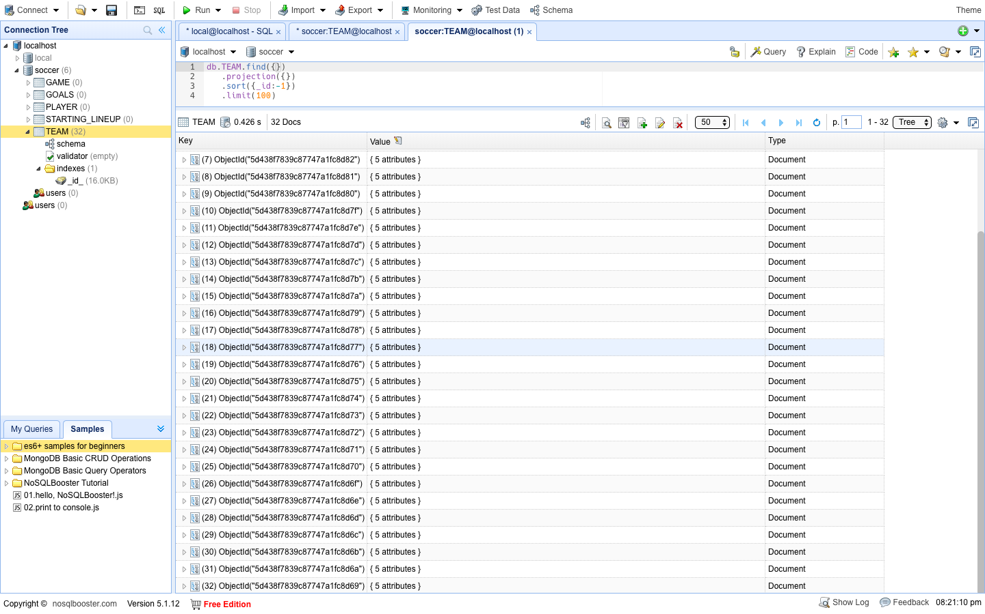

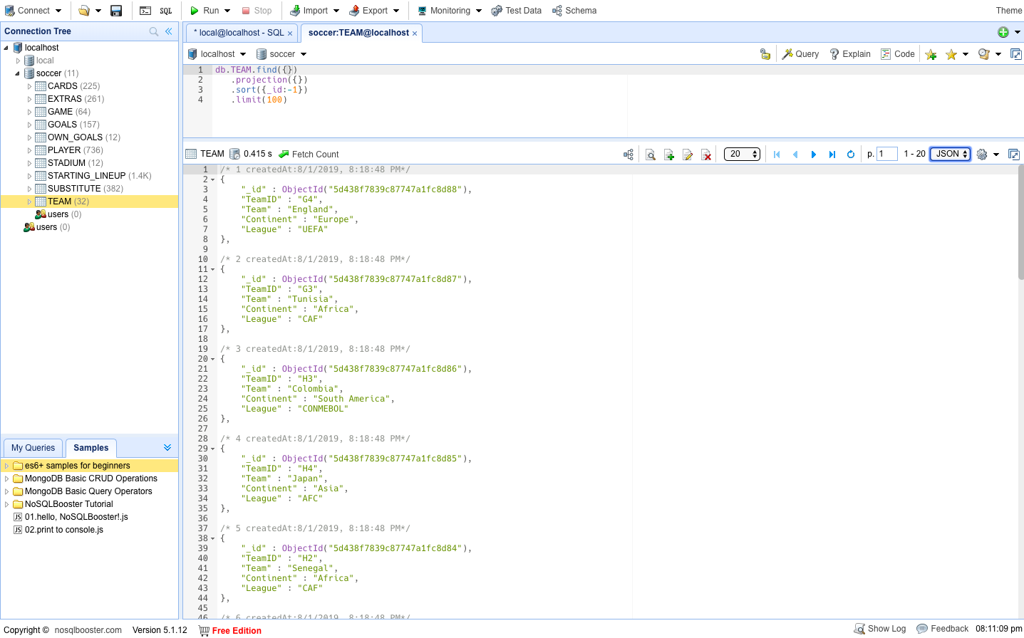

Follow the same importing steps as above and import into other collections: -

1. Importing data into **GAME collection**

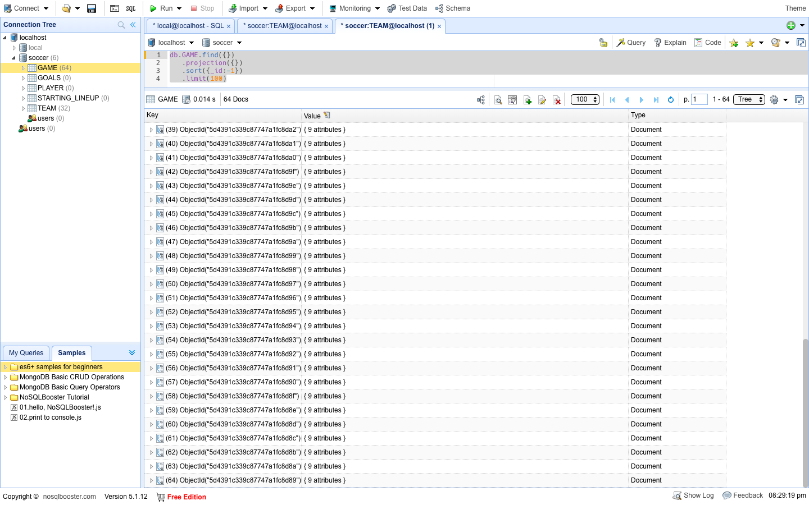

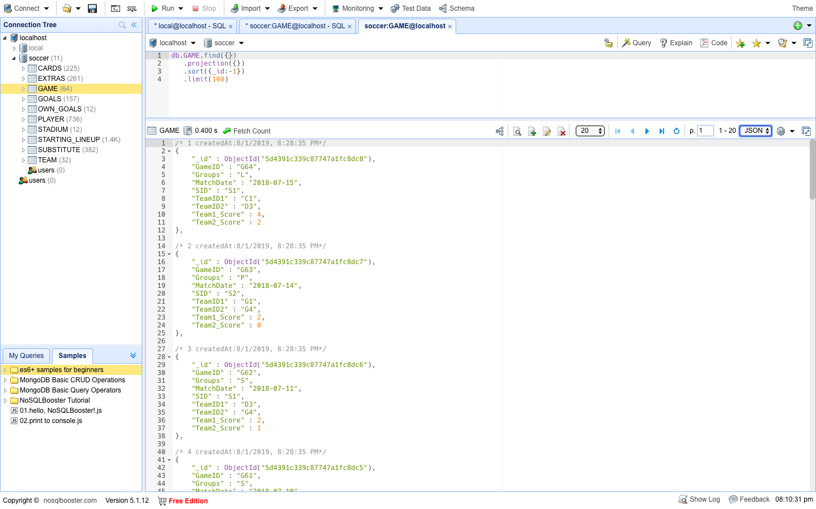

1. Importing data into **PLAYER collection**

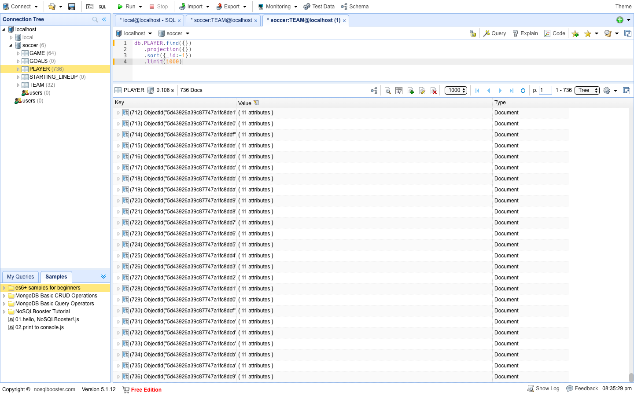

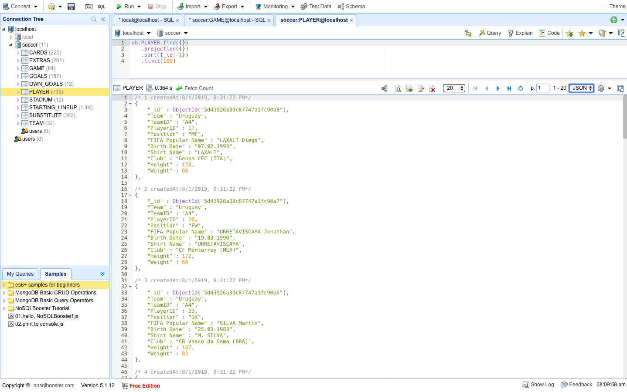

1. Importing data into **STARTING_LINEUP collection**

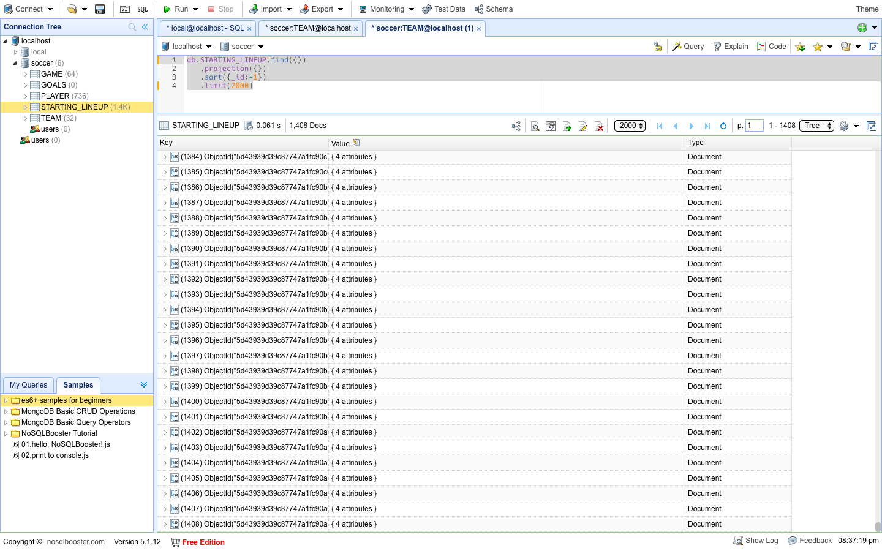

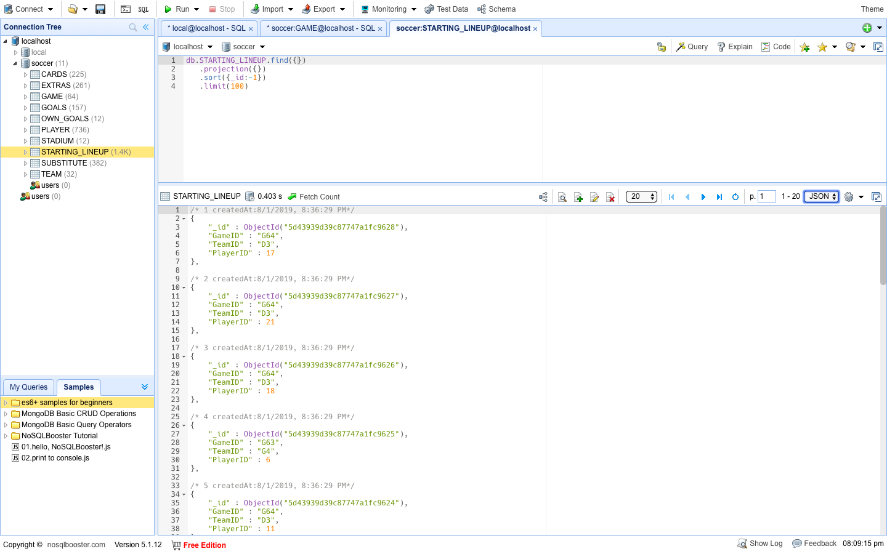

1. Importing data into **GOALS** **collection**

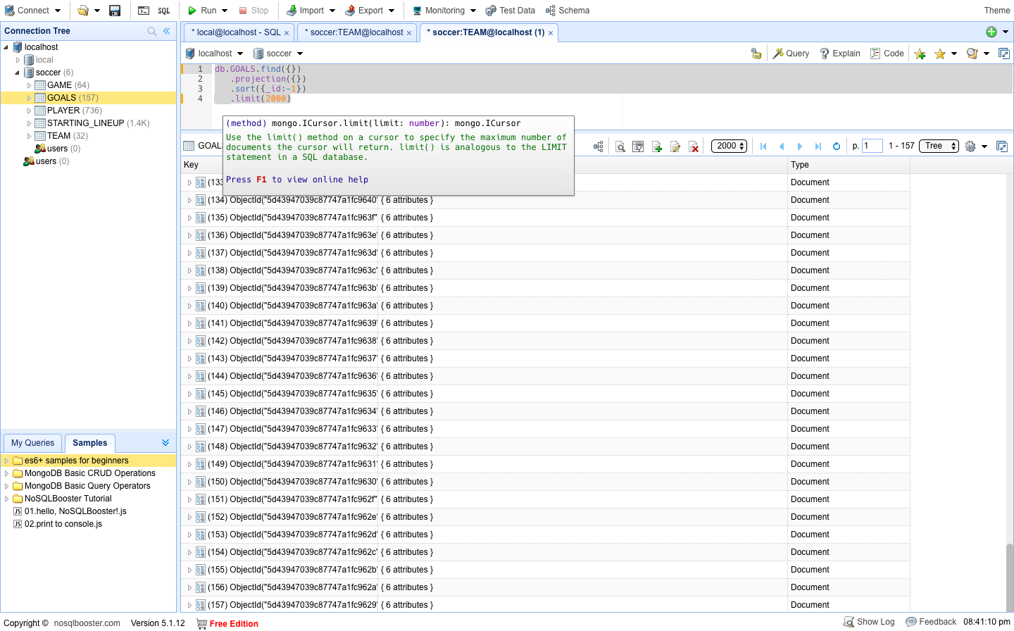

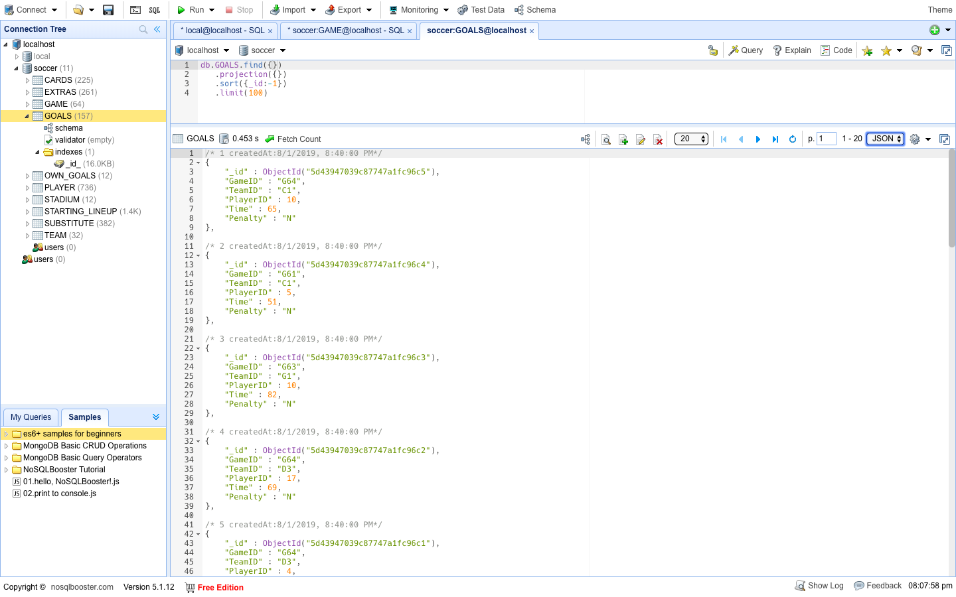

1. Importing data into **OWN**_**GOALS** **collection**

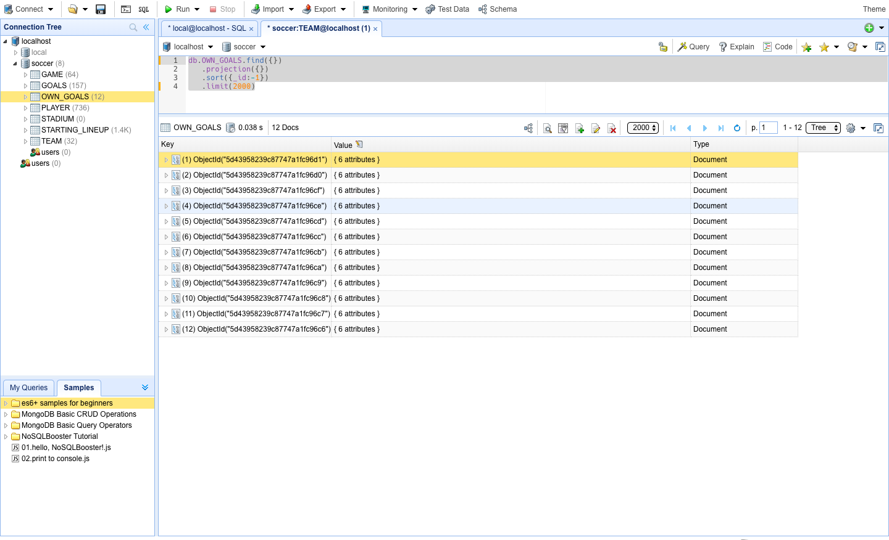

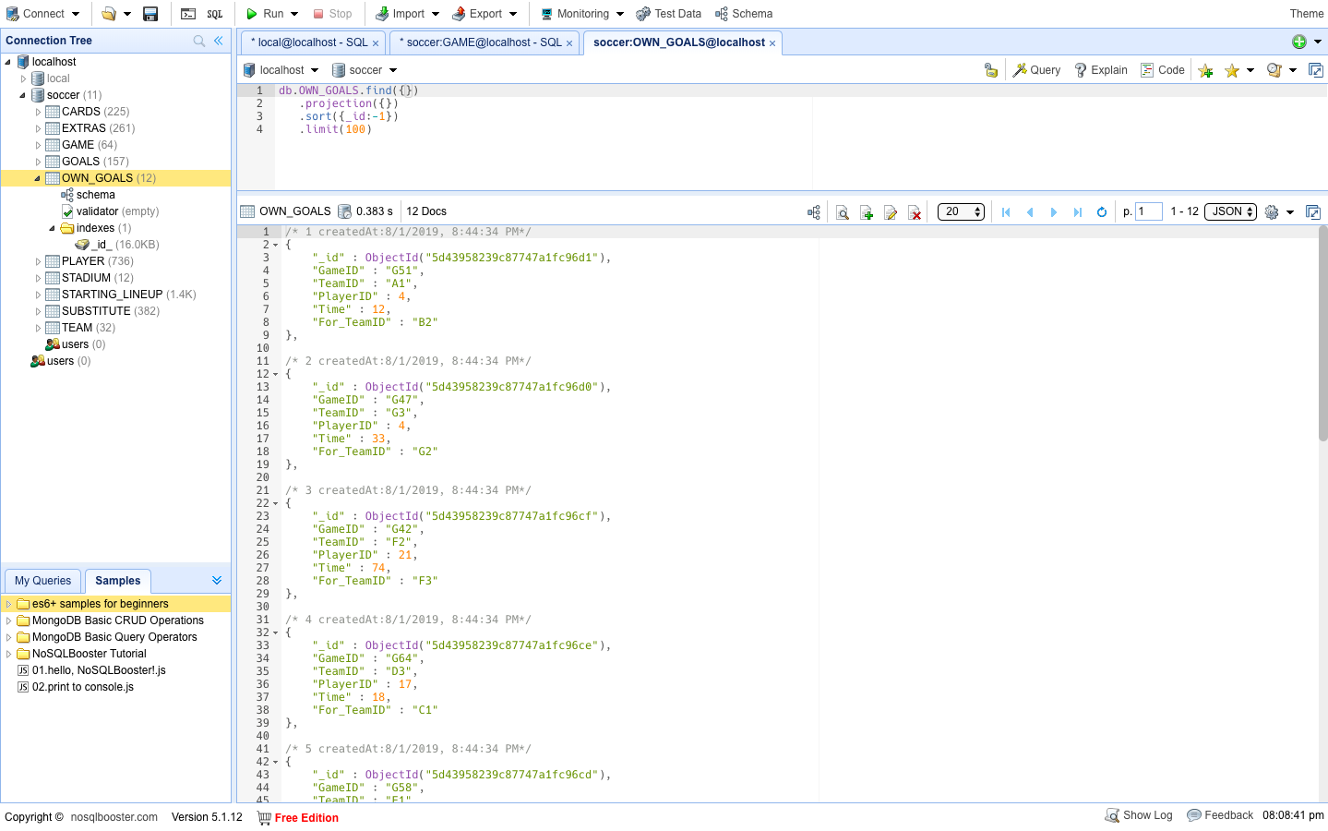

1. Importing data into **STADIUM** **collection**

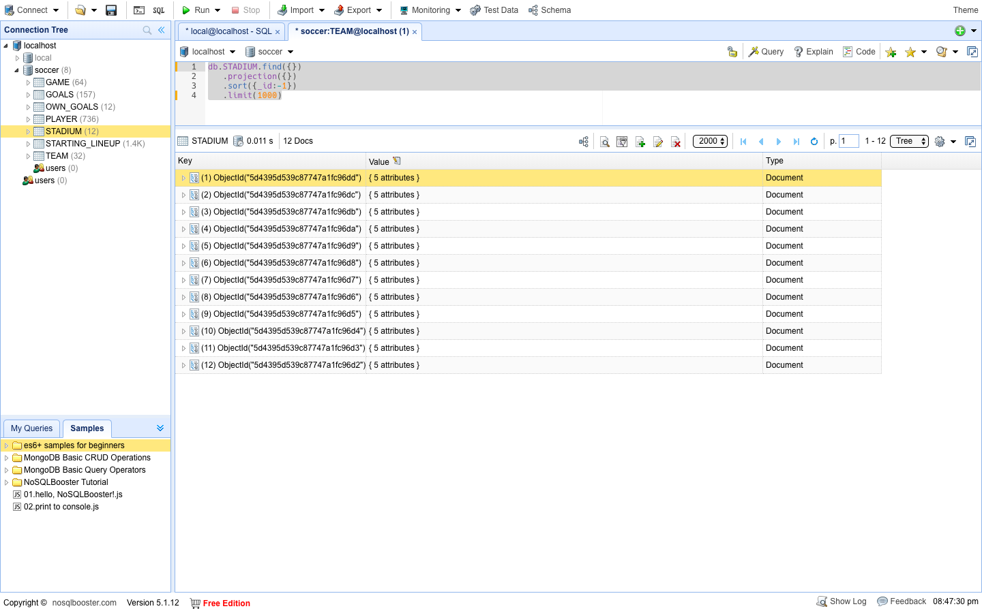

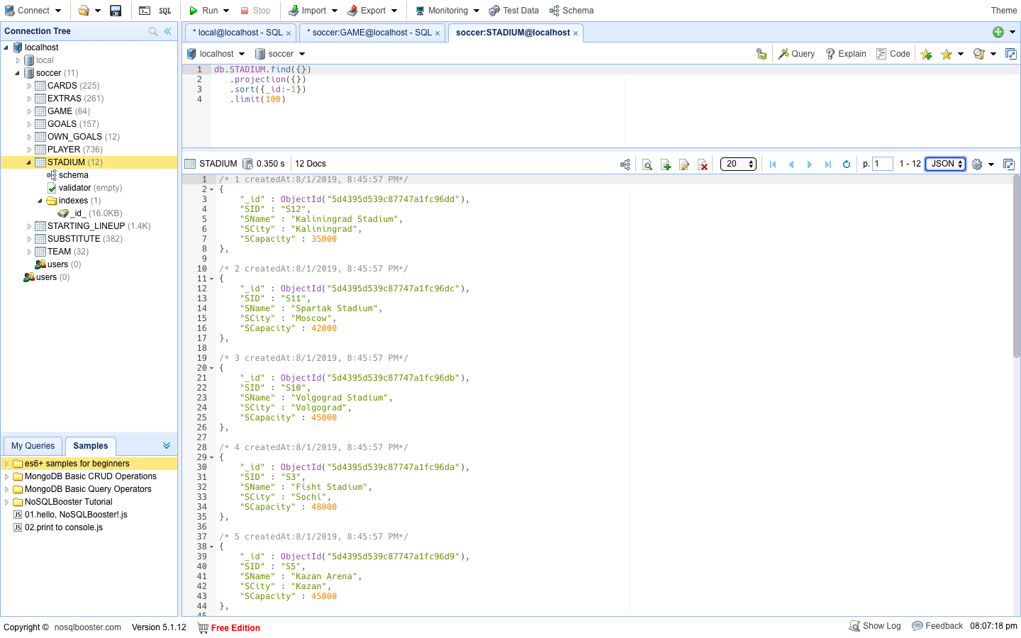

1. Importing data into **CARDS collection**

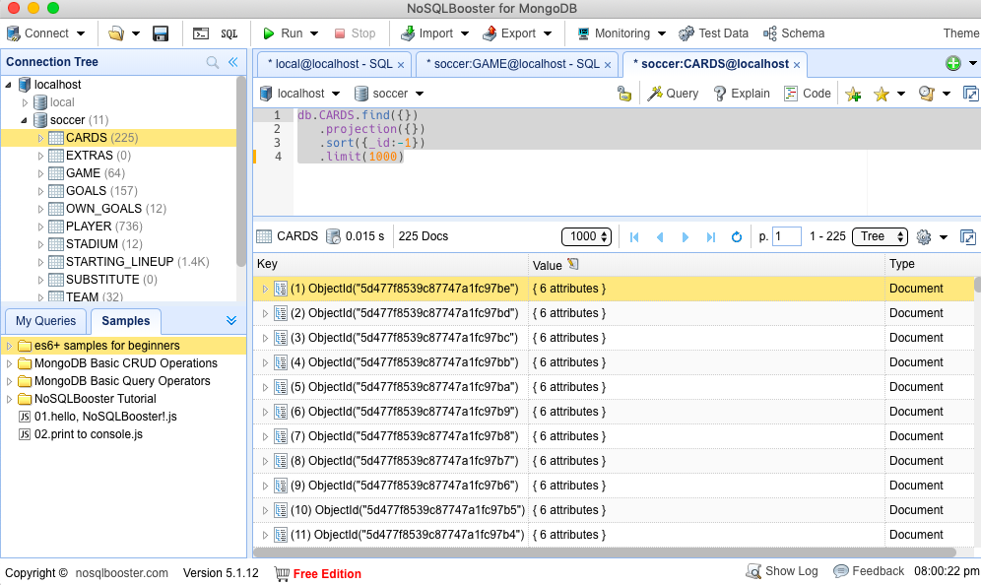

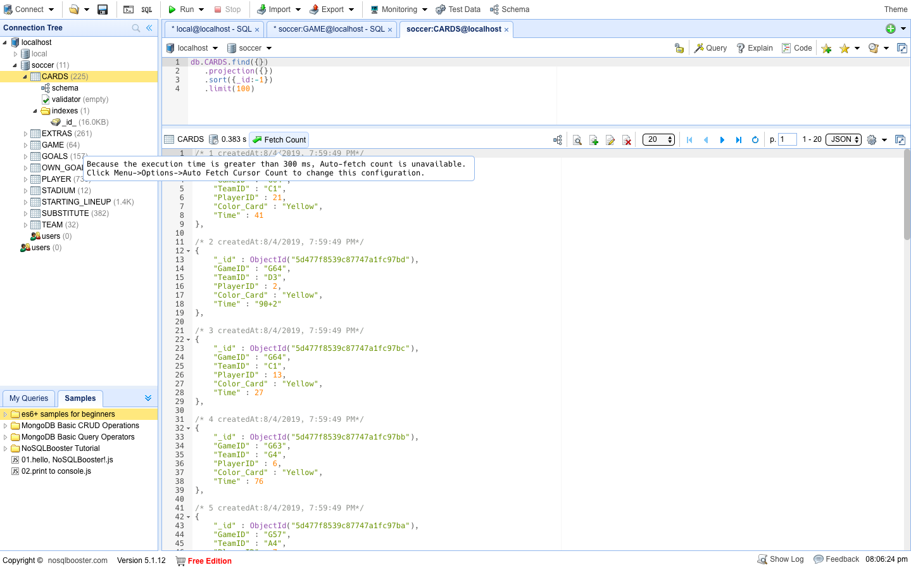

1. Importing data into **EXTRAS collection**

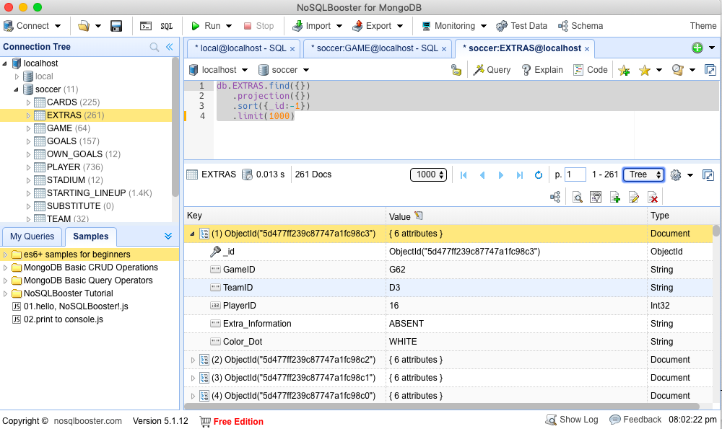

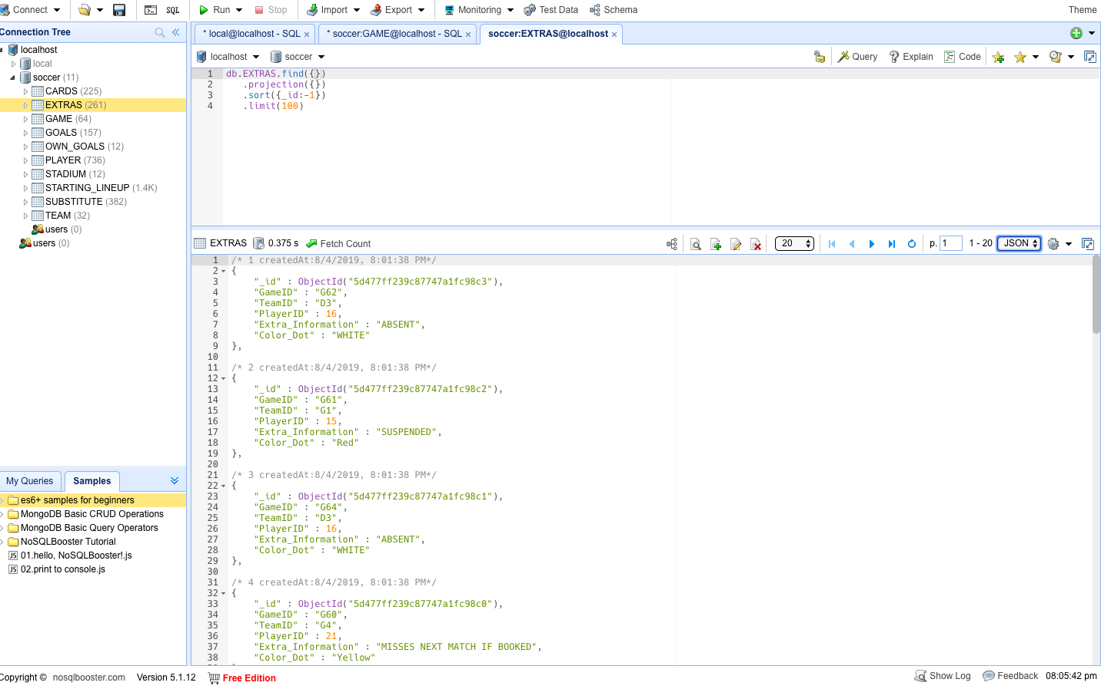

1. Importing data into **SUBSTITUTE collection**

